Student worksheet

4.1 The properties of matter can be described

Pages 62–63 and 178

Properties of matter

1 What is matter?

2 What two things must substances have in order to be called matter? Explain how each is measured.

Part 1 – Solids, liquids and gases

3 Are the substances in the following images solids, liquids or gases or a mixture?

|  |  |  |  |  |
| --- | --- | --- | --- | --- |
| SW0301_01361-r | SW0302_01361-r | SW0303_01361-r | SW0304_01361-r | SW0305_01361-r |
|  |  |  |  |  |

|  |  |  |  |  |
| --- | --- | --- | --- | --- |
| SW0306_01361-r | SW0307_01361-r | SW0308_01361-r | SW0309_01361-rf | SW0310_01361-r |
|  |  |  |  |  |

Part 2 – Chemical and physical properties

4 Name three things you could look for to know that a chemical reaction has occurred.

5 What are physical properties of matter?

6 What are the physical properties of the following substances?

a 

b 

Extend your understanding

7 Are the following situations examples of physical or chemical properties? Explain why.

a Water boils at 100ºC

b Diamond is used to cut glass

c Salt dissolves in water

d Paper is flammable

e Magnesium metal burns to form a white powder

f Nitrogen is a gas at room temperature

g A ball of aluminium sinks faster in water than a piece of aluminium foil does

h If your car is left in the rain, the iron will form rust

Student worksheet

4.2 Scientists’ understanding of matter has developed over thousands of years

Pages 64–65

An introduction to particle theory

Part 1 – Scientists’ contribution to particle theory

1 What is required before an idea becomes a scientific theory?

2 What does the word atom mean?

3 Why was this word used to describe atoms?

4 Who first used this word to describe particles?

5 Name two things that modern chemistry was able to discover about particle theory that Dalton and Democritus were not.

Part 2 – How do particles behave in solids, liquids and gases?

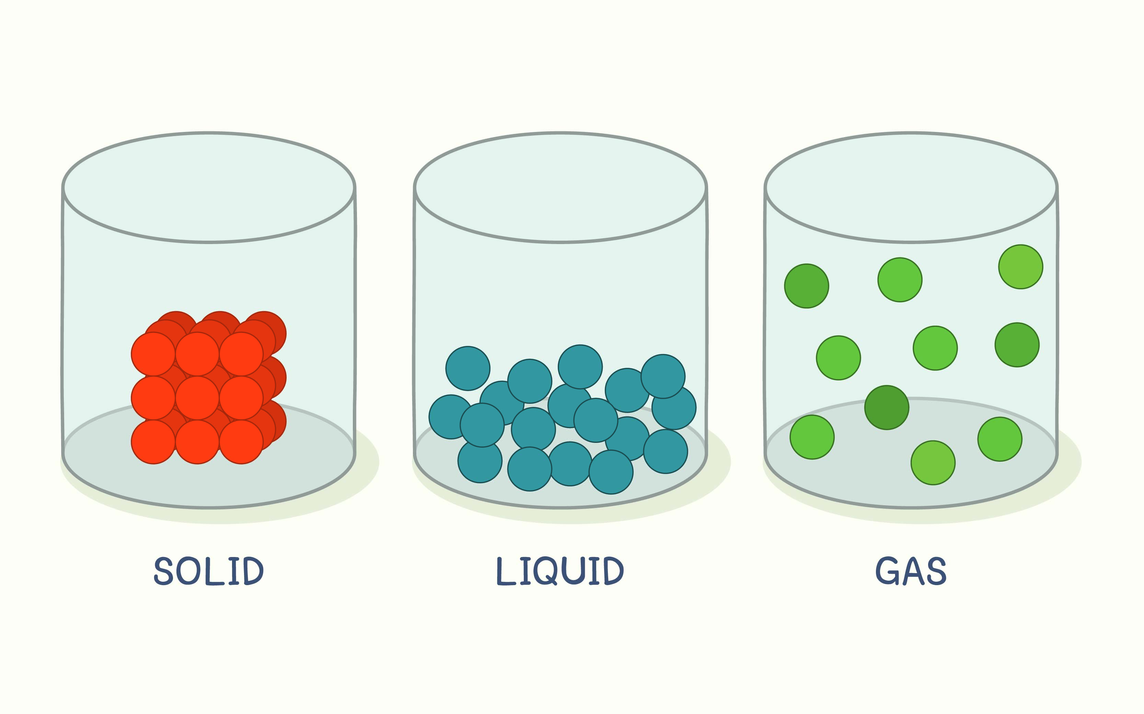

6 States of matter differ in several ways. Using the diagram above, describe how a solid, liquid and gas are different in

a the closeness of particles

b the movement of particles

c how well particles fill a container

7 Using Figure 4.6 in your student book, explain the difference between an atom and a molecule.

8 Look around the room and find three things that are solids, two things that are liquids and at least one gas.

Extend your understanding

There is a fire drill at your school. You are sitting in your science class at tables of four people completing an activity that requires you to swap seats every two minutes. When the bell sounds, everyone freezes to wait for the teacher’s instructions and then makes a mad rush for the door. You and your classmates must bunch together in order to get out, as there is only one door. Once out of the classroom, you all spread apart and run very fast to get to your assembly point. At the assembly point, your teacher asks the class to sit in two straight lines while they take the roll.

9 Using the above analogy, explain which parts represent a solid, a liquid and a gas.

Student worksheet

4.3 The particle model explains matter

Pages 66–67 and 179

Using the particle model to explain matter

Part 1 – Kinetic theory of matter

1 Analogies are an excellent way of visualising the states of matter. Explain which state of matter the following analogies refer to using the kinetic theory of matter:

|  |  |  |
| --- | --- | --- |
| Eggs in a carton | SW0414_00951 | State of matter:    Explanation: |
| Balls in a ball pit | SW0415_00951 | State of matter:    Explanation: |

|  |  |  |
| --- | --- | --- |
| A school of fish swimming in all directions | SW0417_00951-r | State of matter:    Explanation: |
| A tower built out of Lego blocks | SW0418_00951-r | State of matter:    Explanation: |
| Dandelion fluff forming aircrafts in the sky | SW0416_00951 | State of matter:    Explanation: |

Part 2 – Diffusion

2 Explain why particles in the solid state cannot diffuse.

3 Spray air fresheners and liquid diffusers are often used around the home.

 

If you spay air freshener on one side of the room, you can typically smell it in a very short space of time. Explain why this is.

4 If a liquid diffuser were used instead of a spray air freshener, would it take you more or less time to smell the fragrance? Explain your answer.

5 The following diagram represents a teabag in a hot cup of water. In the glasses provided, draw the particles to demonstrate what happened to the tea as it diffused throughout the water.

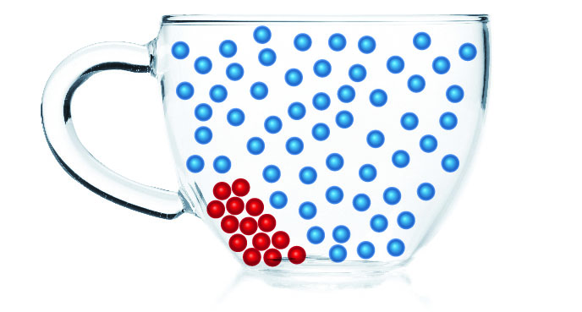® 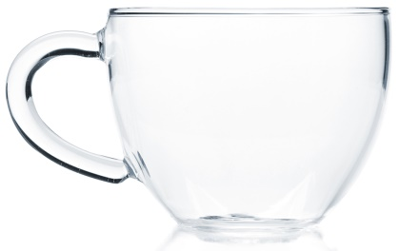 ® 

Extend your understanding

6 Explain why 5 g of lead is much smaller than 5 g of aluminium (use the periodic table on page 73 of your student book and elemental atomic mass to explain your answer)

7 Using the atomic masses you found in question 6, calculate the mass of each of the following aluminium and lead cubes. Using you understanding, explain why 1 cubic centimetre of tungsten weighs 19.25 g, but the same amount of lithium weighs 0.53 g.

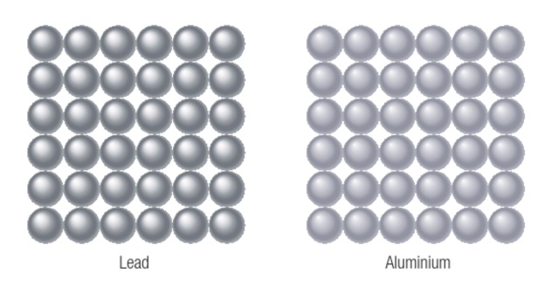

Student worksheet

4.4 The particle model can explain the properties of matter

Pages 68–69 and 180

Using the particle model to explain properties of matter

Part 1 – Strength

1 What is tensile strength?

2 Would a piece of wire or a rubber band have greater tensile strength? Explain your answer.

 

3 What is compressional strength?

4 Would a piece of rock candy or a marshmallow have greater compressional strength? Explain your answer.

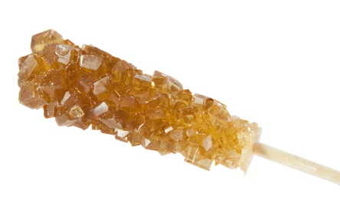 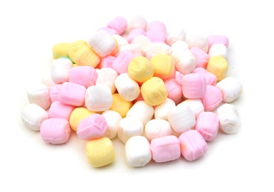

Part 2 – Hardness

5 Explain what a brittle material is.

6 Would graphite or diamond be the most brittle? Explain your answer.

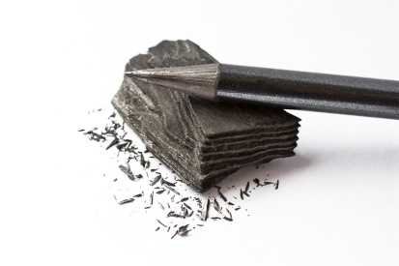 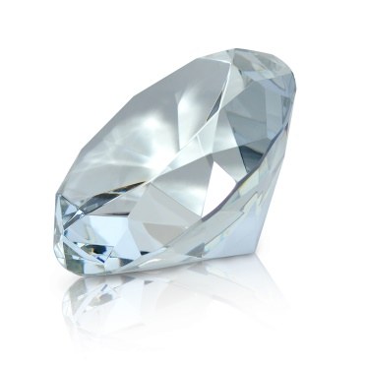

Part 3 – Viscosity

7 Which honey or water would have a greater viscosity? Explain your answer.

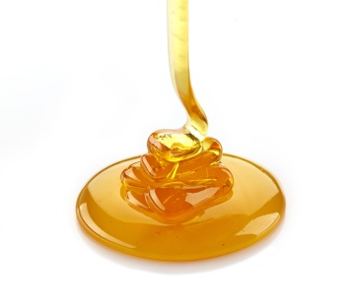 

Part 4 – Compressibility

8 Using your knowledge of the particle model of matter, explain why solids or liquids cannot be compressed.

9 Using your knowledge of the particle model of matter, explain why it is possible to compress a gas.

Part 5 – Density

10 Cork is made of wood, but why is it less dense than water? Use the data from Table 4.2 (page 69) of your student book to answer this question.

Extend your understanding

The Greek Sicilian King Hiero (308–215BC) of Syracuse once had a suspicion that his goldsmith was swapping the gold in the crown for a cheaper alloy. By swapping out the gold, the goldsmith would be able to keep the gold and then sell it to make a profit for himself.

Hiero gave Archimedes (a mathematician, physicist, engineer, inventor, and astronomer) the task of proving these charges. Archimedes knew that the King would not approve of him squashing/melting his crown into a cube to measure its volume and compare it with its mass.

11 How did Archimedes overcome the problem of being unable to squash the King’s crown into a cube? What is the name of the method that measures objects in this way? (Hint: refer to the ‘Density Den’ experiment on page 180 of your student book.)

Student worksheet

4.5 Increasing kinetic energy in matter causes it to expand

Pages 70–71 and 182–184

Heating particles and expansion

Part 1 – Heating particles

1 Complete the diagram by following these instructions.

a In the circles, draw what particles look like in a liquid state and gaseous state (solid has been provided as an example).

b On the black lines, indicate whether each state change requires an increase or decrease in energy, and an increase or decrease in heat (the first has been completed for you as an example).

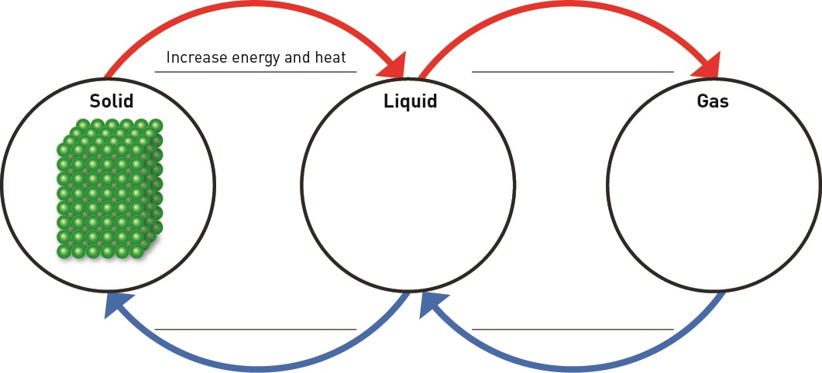

2 What type of energy do the particles that you drew in the above diagram contain?

3 When a solid changes to a liquid,

a what happens to the movement of particles?

b why does particle movement change?

4 When a liquid changes to a gas,

a what happens to the movement of particles?

b why does particle movement change?

Part 2 – Heat causes expansion

5 Train tracks are made of solid metal. Explain why, on hot days, train tracks buckle and trains may not run.

6 Explain why liquids are used in the internal chamber of a mercury thermometer to measure temperature.

7 If you cannot open the lid of a jar of spaghetti sauce, running the metallic lid under hot water will make it easier to open. Explain why this is so.

Extend your understanding

8 Examine the following images.

|  |  |
| --- | --- |
| SW0434_00951-rm | SW0435_00951-rm |
| **A** A metal ball that fits through a hoop | **B** The exact same ball that no longer fits through the exact same hoop |

a Which image demonstrates expansion and which demonstrates contraction?

b Which image shows equipment that has been heated? How do you know?

c Explain, using your knowledge of expansion and contraction, why the ball can both fit through the hoop and not fit through the hoop.

Student worksheet

4.6 Atoms and elements make up matter

Pages 72–73 and 185–187

Atoms, elements and the periodic table

Part 1 – Atoms and elements

1 What is the word atom or *atomos* used to describe?

2 Which is the smallest atom in terms of mass?

3 How many elements are found naturally on Earth?

4 How long does it take an artificial element to break down?

5 What properties do artificial elements have?

6 What is a monoatomic element?

7 Give two examples of a monoatomic element.

8 What is a diatomic element?

9 Give three examples of a diatomic element.

10 The atmosphere is a mixture of many gases. Some of these gases include nitrogen (N2), oxygen (O2) and argon (Ar). Of these three gases, which are monoatomic and which are diatomic?

Part 2 – Periodic table

11 What are horizontal rows called?

12 What are vertical columns called?

13 Where are metals located?

14 Where are non-metals located?

15 What are the names of these elements?

|  |  |  |  |
| --- | --- | --- | --- |
|  |  |  |  |
|  |  |  |  |

16 Which element is located in

a period 2, group 1?

b period 2, group 16?

17 Which atom has an atomic mass of

a 12.01?

b 40.08?

18 Which atom has an atomic number of

a 9?

b 26?

Extend your understanding

The periodic table was first developed by the Russian chemist and inventor, Dmitri Ivanovich Mendeleev. In 1869, he arranged chemical elements into the first periodic table, but there was a problem – not all of the chemical elements had been discovered at the time so he left blank spaced where he predicted future elements would belong.

19 Research the following people and briefly state the major discovery they made to the periodic table and the year it occurred in.

a Robert Boyle

b John Newland

c Marie and Pierre Curie

d Sir William Ramsay and Lord Rayleigh

e Glenn Seaborg

20 Some of these chemists have been given one of the highest honours for their discoveries. What honour did the Curies, Mendeleev and Seaborg receive?

Student worksheet

4.7 Atoms bond together to make molecules and compounds

Pages 74–75 and 188

Molecules, compounds and mixtures

Part 1 – Molecules

1 What is the difference between a molecular element and a molecular compound?

2 Name and draw two examples of molecular elements below (an example has been provided for you).

|  |  |  |
| --- | --- | --- |
| Hydrogen  SW0445_00951 |  |  |

3 Name and draw two examples of molecular compounds below (an example has been provided for you).

|  |  |  |
| --- | --- | --- |
| Hydrogen peroxide  SW0444_00951 |  |  |

Part 2 – Compounds and mixtures

4 What is a compound?

5 What is a mixture?

6 Name and draw two examples of compounds below (an example has been provided for you).

|  |  |  |
| --- | --- | --- |
| Water  SW0446_00951 |  |  |

7 Draw two examples of mixtures below (an example has been provided for you).

|  |  |  |
| --- | --- | --- |
| SW0451_00951 |  |  |

8 What is the difference between a molecular compound and a compound?

9 Complete the chart of the different types of substances from your student book, and draw examples of the bottom three substances in the boxes provided.

**Example**

**Example**

**Example**

Extend your understanding

10 State whether the following diagrams represent an atom of an element, a molecule of an element, a compound or a mixture.

|  |  |  |  |
| --- | --- | --- | --- |
| SW0440_00951 | SW0447_00951 | SW0446_00951 | SW0448_00951 |
| SW0442_00951 | SW0449_00951 | SW0441_00951 | SW0450_00951 |
| SW0451_00951 | SW0444_00951 | SW0452_00951 | SW0443_00951 |